**Vectors**

**Vector-Vector Multiplication**

When you say "multiply two vectors," there are actually several ways to perform operations involving vectors. The most common vector operations include:

1. **Dot Product (Scalar Product):** The dot product of two vectors A and B is a scalar (a single value) and is denoted by A · B. The two vectors (A and B) must have the same dimension. In other words, they should have the same number of components.
2. **Cross Product (Vector Product):** The cross product of two vectors A and B results in another vector. It is denoted as A × B. The cross product is only applicable to three-dimensional vectors, and vectors of different dimensions cannot be used with the cross product operation. The result of the cross product is itself a three-dimensional vector.
3. **Hadamard Product (Element-wise Product):** The Hadamard product of two vectors A and B results in a new vector of the same dimension. It is denoted as (A ⊙ B). The input vectors (A, B) should have the same dimension. You perform element-wise multiplication between corresponding components of the input vectors, so they need to have the same number of components.

It is denoted as (A ⊙ B).

(A ⊙ B)_i = A_i * B_i, for each component i.

Hadamard addition, also known as element-wise addition, is a mathematical operation performed on two vectors or matrices of the same dimensions.

1. **Outer Product:** The outer product of two vectors u and v results in a matrix, where each element (i, j) of the matrix is the product of the i-th component of u and the j-th component of v. It is denoted as (u ⊗ v). The dimensions of the resulting matrix depend on the dimensions of the input vectors (u, v). If vector u has m components and vector v has n components, the resulting matrix will have dimensions m x n.

Given two vectors of size m x 1 and n x 1 respectively

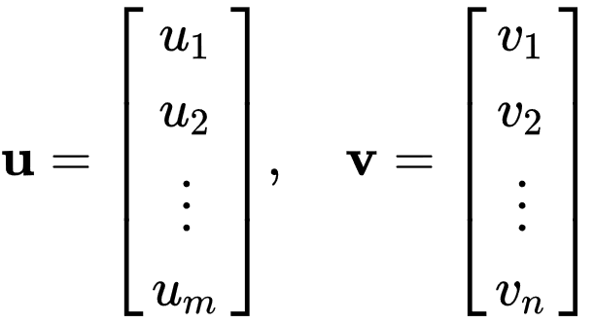

their outer product, denoted �⊗�,( **u** ⊗ **v**) is defined as the m x n �×�matrix A o�mmbtained by multiplying each element of **u** �by each element of **v** �

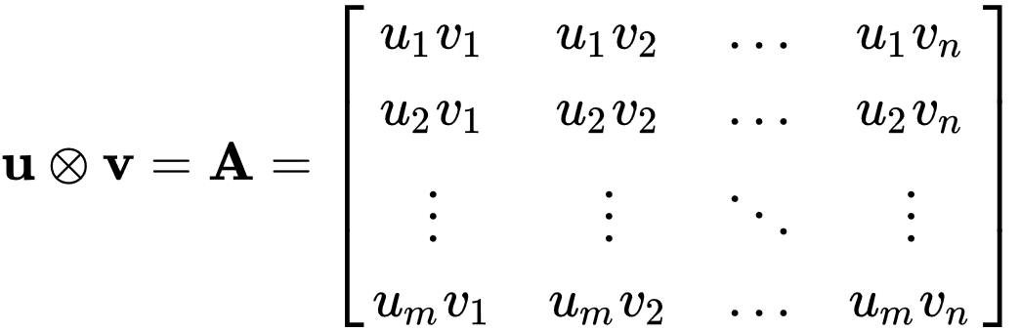

**Scalar-Vector Multiplication**

When you multiply a scalar (a single numerical value) by a vector, you are performing scalar-vector multiplication, which is an elementary operation in linear algebra. This operation involves multiplying each component of the vector by the scalar value. The result is a new vector where each component has been scaled by the scalar.

Mathematically, if you have a scalar k and a vector A with components A1, A2, A3, ..., An, the result of the scalar-vector multiplication is a new vector B with components B1, B2, B3, ..., Bn, calculated as follows:

B1 = k * A1 B2 = k * A2 B3 = k * A3 ... Bn = k * An

**Scalar-Vector Addition**

When you add a scalar (a single numerical value) to a vector, you are performing scalar-vector addition. In this operation, the scalar is added to each component of the vector, resulting in a new vector where each component has been increased by the scalar value.

Mathematically, if you have a scalar k and a vector A with components A1, A2, A3, ..., An, the result of the scalar-vector addition is a new vector B with components B1, B2, B3, ..., Bn, calculated as follows:

B1 = A1 + k B2 = A2 + k B3 = A3 + k ... Bn = An + k

**Matrix Multiplication vs Dot Product**

Matrix multiplication and the dot product are two distinct mathematical operations, and they are not the same. Matrix multiplication is an operation defined for matrices, while the dot product is an operation defined for vectors.

Let's clarify both operations:

1. **Matrix Multiplication:** Matrix multiplication involves multiplying two matrices to produce a new matrix. To perform matrix multiplication, the number of columns in the first matrix must be equal to the number of rows in the second matrix. The result is a new matrix with dimensions determined by the dimensions of the input matrices.

For two matrices, A (m x n) and B (n x p), their matrix product (A * B) results in a new matrix C (m x p), where each element C(i, j) is calculated by taking the dot product of the i-th row of matrix A and the j-th column of matrix B.

1. **Dot Product:** The dot product is an operation performed on two vectors (which can be considered as 1 x n or n x 1 matrices). The dot product results in a scalar (a single value). It is calculated by taking the sum of the products of the corresponding elements of the two vectors.

For two vectors, A and B, the dot product A · B is calculated as:

A · B = A1 * B1 + A2 * B2 + ... + An * Bn

Matrix multiplication is basically a matrix version of the dot product. Remember the result of dot product is a scalar. The result of matrix multiplication is a matrix, whose elements are the dot products of pairs of vectors in each matrix. These operations have different mathematical definitions and are not equivalent.